TECHNOLOGY ARCHITECTURE

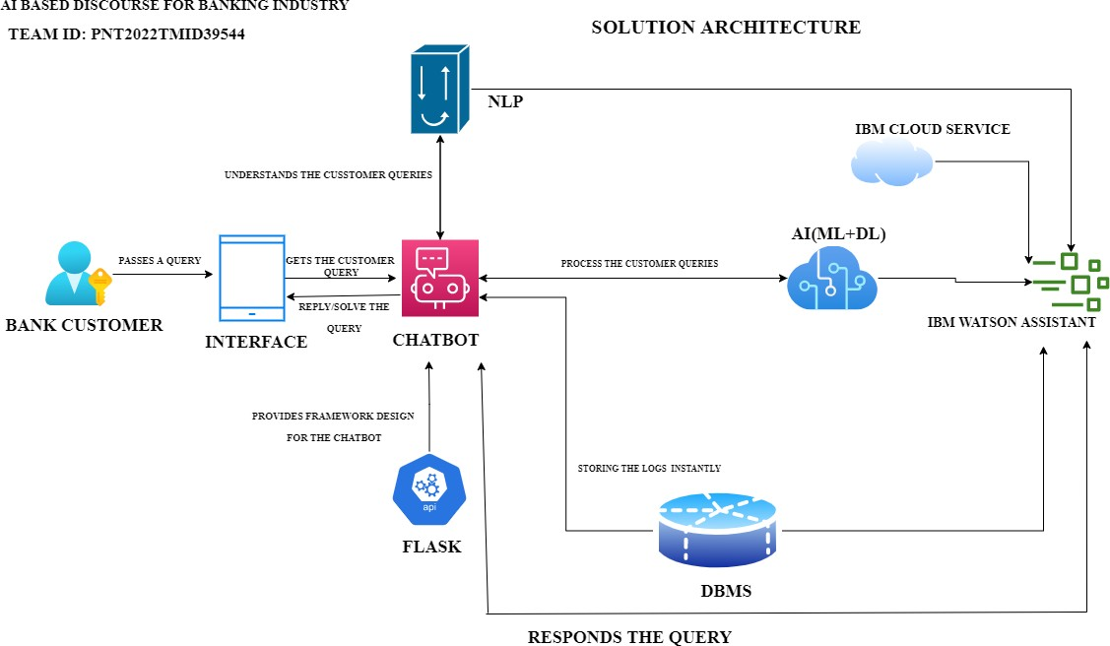

Table 1 : Components & Technologies:

|  |  |  |  |
| --- | --- | --- | --- |
| **S.No** | **Component** | **Description** | **Technology** |
| 1. | User Interface | Chatbot | HTML, CSS, JavaScript / Angular Js / React Js etc. |
| 2. | Application Logic-1 | Query Processing | NLP and NLU |
| 3. | Application Logic-2 | Dealing with Dataset | IBM Watson STT service |
| 4. | Application Logic-3 | Training and Building Deep Learning Model | IBM Watson Assistant |
| 5. | Database | Data Type –Dialog, Intent, etc. Configurations are done using small integration Code snippets such as Javascript, and SQL and can also be done using Watson APIs. | MySQL or NoSQL or IBM DB2 |
| 6. | Cloud Database | Database Service on Cloud | IBM DB2, IBM Cloudant etc. |
| 7. | File Storage | We store dataset | IBM Block Storage or Other Storage Service or Local Filesystem, IBM Cloud, IBM Watson studio |
| 8. | External API-1 | To incorporate conversation, language, and advanced text analytics into the chatbot | IBM Watson Assistant API,v2 runtime API, etc. |
| 9. | External API-2 | Banking API –Data transfer between two systems and data accessibility | Banking API, etc. |
| 10. | Machine Learning Model | Intent detection model and other deep learning models | Object Recognition Model, Intent detection model, IBM Watson studio, etc. |

|  |  |  |  |
| --- | --- | --- | --- |
| 11. | Infrastructure (Server / Cloud) | On the cloud server, we will be deploying the chatbot using flask on the web page  : | Python Flask etc. |

Table 2: Application Characteristics:

|  |  |  |  |
| --- | --- | --- | --- |
| **S.No** | **Characteristics** | **Description** | **Technology** |
| 1. | Open-Source Frameworks | Open-source frameworks used is IBM Watson | The technology of Opensource framework- IBM Watson |
| 2. | Security Implementations | IBM Cloud | Watson assistant has certifications such as ISO, SOC2, US HIPAA,  European Union GDPR, PCI DSS. We use security systems such as TCS/SSL,IPSEC, Third party CAs, HTTPS,  Encrypted file systems, Encrypted storage systems, Key management systems, AES -  256 bit. |
| 3. | Scalable Architecture | Chatbot architecture consists of four pillars. They are intents, entities, data flow, and scripts | The technology used –IBM Watson Assistant |
| 4. | Availability | The Bot is made available using load balancers, distributed servers, etc. | The technology used –IBM Watson Assistant |
| 5 | Performance | IBM Watson –automate processes, The deep learning model is trained using IBM Watson studio for better performance, Cache, CDNs, etc. | Watson Assistant is used to build the chatbot. |